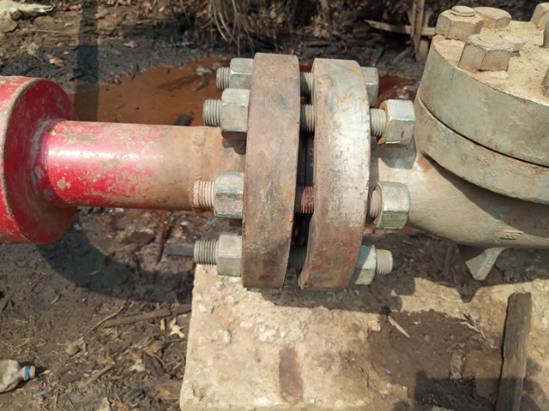
Picture showing loosened nuts on the bolts of the flange. This is the point of spill.
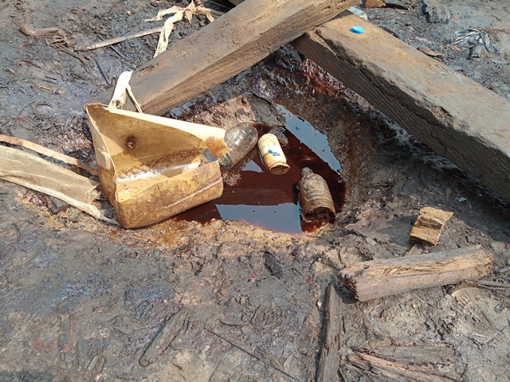
Impacted area

